**Newton Raphson Method**

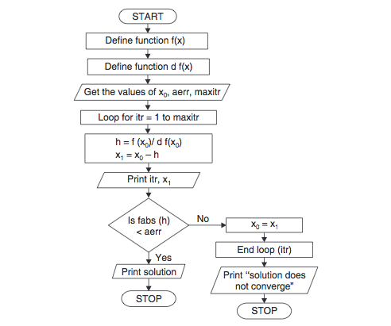

**Algorithm for Newton Raphson Method**

1. Start

2. Define function as f(x)

3. Define first derivative of f(x) as g(x)

4. Input initial guess (x0), tolerable error (e) and maximum iteration (N)

5. Initialize iteration counter i = 1

6. If g(x0) = 0 then print "Mathematical Error" and goto (12) otherwise go to (7)

7. Calculate x1 = x0 - f(x0) / g(x0)

8. Increment iteration counter i = i + 1

9. If i >= N then print "Not Convergent" and go to (12) otherwise go to (10)

10. If |f(x1)| > e then set x0 = x1 and go to (6) otherwise go to (11)

11. Print root as x1

12. Stop